|  |  |  |  |
| --- | --- | --- | --- |
| Process Title | BEST Prioritization Matrix Sheet Automation | | |
| Affected Department | NAM BEST TEAM | | |
| Process Owner |  | | |
| Initial Document Creation Date | 04/17/2023 | Last Revision Date |  |

Contents

Document Purpose 2

Scope of Work 2

Prerequisites / Required Accesses 2

Responsibilities 2

Process Instructions 2

Additional Resources / Links to Other Documentation / References 2

Revision History 2

***Note:*** *Update Table of Contents after making changes so that page numbers are reflected correctly.*

# Document Purpose

This document describes the process to update BEST Prioritization Matrix sheet with new EPIC data through Python Script automation.

# Process Instructions

**Environment Setup Steps:**

1. Install Python in your machine through below website:



1. Go to Downloads and click on Windows:

1. Click on highlighted link:

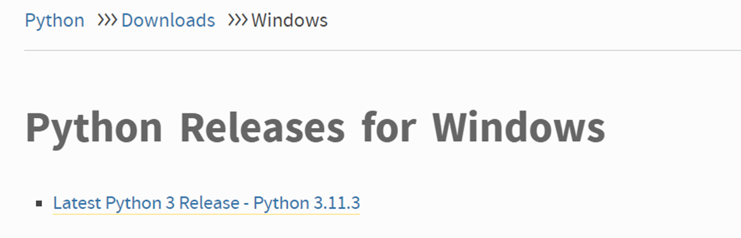

1. Click on Installer to download as per your system specifications (Windows or macOS):

1. Once downloaded, click on .exe file:

1. Click on Install now:

**Please deselect the “Use admin privileges when installing py.exe”**

1. Once downloaded, open Command Prompt from windows search box.

1. Type “python --version” to check if python successfully installed or not.

**EPIC Data Download Steps:**

1. In EPIC sharepoint, Create a new view with just three columns(Title, Proposed Improvement, Logged by) as mentioned:

1. Add below filters and click on Ok

1. Export to Excel:

1. Open the downloaded excel file:

1. Copy column A, B and C and paste it to new tab sheet beside. A screenshot of a computer

   Description automatically generated with medium confidence
2. Save the excel file as “EPIC_Data.xlsx” .

1. Please sync the below SharePoint folder to your machine if not synced yet.A screenshot of a computer

   Description automatically generated with low confidence
2. Paste the file in below location in your machine.

**Python Script run:**

1. Open IDLE from Windows search box:

1. Go to File > Open :

1. Select BEST Prior_matrix.py file cloned through Git hub:

1. Once the script is opened, replace the ID in path with your ID for both files.   
   For master sheet and For epic data: Replace highlighted field with your ID.

1. Click on Run and Click Run Module to execute the python script:

# Revision History

*Each time a revision is made to this document, include who made the changes and what about the document changed for tracking purposes.*

|  |  |  |  |
| --- | --- | --- | --- |
| Revision | Name | Date | Changes Made |
| A | Manuja Jain | 04/24/2023 | Document completed with steps required to download python, download EPIC data and executing script. |
| B |  |  |  |
| C |  |  |  |
| D |  |  |  |
| E |  |  |  |
| F |  |  |  |